**Google Workspace (formerly G Suite) - Notes**

**Overview:** Google Workspace is a suite of cloud-based productivity and collaboration tools for businesses, schools, and organizations.

**Core Apps in Google Workspace:**

1. **Gmail** – Business email with your domain (e.g., [you@yourcompany.com](mailto:you@yourcompany.com))
2. **Google Drive** – Cloud storage and file sharing
3. **Google Docs, Sheets, Slides** – Real-time collaboration on documents
4. **Google Meet & Chat** – Video conferencing and messaging
5. **Google Calendar** – Shared calendars and scheduling
6. **Google Admin Console** – Manage users, devices, and settings
7. **Google Vault** – Data retention and eDiscovery (Business plans and up)

**Key Benefits:**

* Custom email addresses with your domain
* Admin control over users and security
* Seamless integration across collaboration tools
* Cloud-native with auto-save and version history
* Scalable for teams of all sizes

**Pricing (as of 2025):**

* **Business Starter**: ~£4.60/user/month – 30 GB storage/user
* **Business Standard**: ~£9.20/user/month – 2 TB storage/user
* **Business Plus**: ~£13.80/user/month – 5 TB storage/user + more security
* **Enterprise**: Custom pricing – Unlimited storage, advanced security & compliance

**Signing Up:**

Start a 14-day free trial at [workspace.google.com](https://workspace.google.com). You need a domain name (can buy during setup).

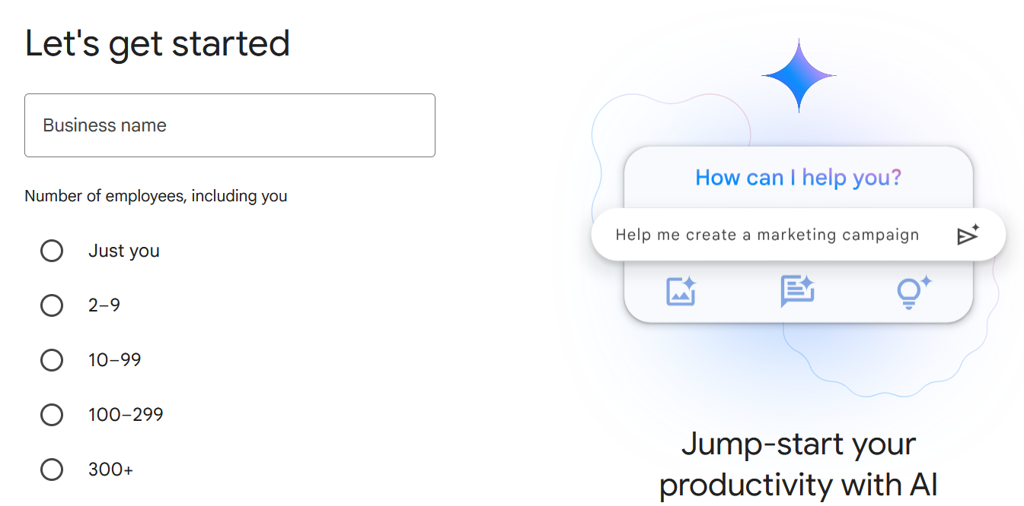

**Cloud Identity in Google:**

Standalone IAM service for managing users, devices, and apps, usable even without full Google Workspace.

In this scenario company will integrate their AD with cloud identity for authentication and authorization.

**Types of Cloud Identity:**

1. **Cloud Identity Free:**
   * Basic identity services
   * User management and SSO
   * No cost
   * No Gmail/email features
2. **Cloud Identity Premium:**
   * Everything in Free
   * Advanced device/app management

**✅ Step-by-Step: Create Google Cloud Identity Account**

**1. Go to the Cloud Identity signup page**

Visit: https://cloud.google.com/identity

Click **"Get Started for Free"** or **“Try Cloud Identity”**.

**2. Start the setup wizard**

* Click on **“Start Setup”**
* Choose **“For My Business”**, **“For My School”**, or **“For Myself”** as appropriate.

Individual account:

An **Individual Account** in **Google Cloud** typically refers to a **personal Google Account** (like you@gmail.com) that is used to access Google Cloud Platform (GCP) services **without being part of a larger organization** (e.g., company, school).

Google Workspace and Identity types of accounts have the following organizational structure (Stucture1)

1. Organization: This node is the root of the GCP resource hierarchy and represents your company (organization). This allows to centrally mange access control policies across all the GCP resources. This is automatically create with G suite or cloud identity account

2. Folders: Folders help you group related projects with in your company. They can reprsent different departments or business units. Folders can be nested

3. Projects: These are basic organizing units in GCP, where you create resources. Projects create isolation between resources.

4. Resources: These are individual services such as Compute Engine instance, Cloud storage bucket, BigQuery dataset, GKE

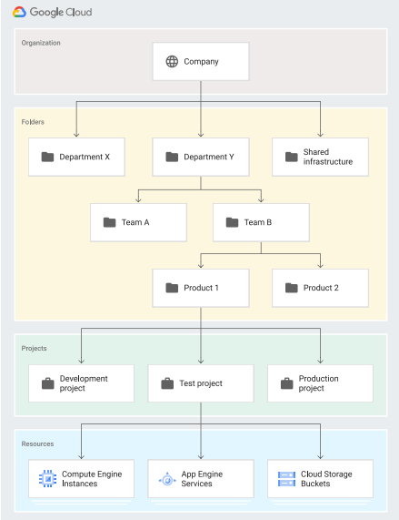

For individual accounts we have following structure

1. Projects: These are basic organizing units in GCP, where you create resources. Projects create isolation between resources.

2. Resources: These are individual services such as Compute Engine instance, Cloud storage bucket, BigQuery dataset, GKE Every Project in GCP gets a unique id

GCP console link: <https://console.cloud.google.com/welcome/new>

